FIFO
#include <stdio.h>

int main() {
int pages[50], frames[10];
int n, f, i, j;
int pageFaults = 0;
int next = 0;
int found;

printf("Enter number of pages: ");
scanf("%d", &n);

printf("Enter page reference string:\n");
for(i = 0; i < n; i++) {
scanf("%d", &pages[i]);
}

printf("Enter number of frames: ");
scanf("%d", &f);

for(i = 0; i < f; i++) {
frames[i] = -1;
}

printf("\n--- FIFO Page Replacement ---\n");

for(i = 0; i < n; i++) {

found = 0;

for(j = 0; j < f; j++) {
if(frames[j] == pages[i]) {
found = 1;
break;
}
}

if(found == 0) {
frames[next] = pages[i];
next = (next + 1) % f;
pageFaults++;
}

printf("Page %d -> [", pages[i]);

for(j = 0; j < f; j++) {
if(frames[j] != -1)
printf("%d", frames[j]);
else
printf(" ");

if(j != f - 1)
printf(" ");
}

printf("]\n");
}

printf("\nTotal Page Faults (FIFO): %d\n", pageFaults);

return 0;
}
OUTPUT
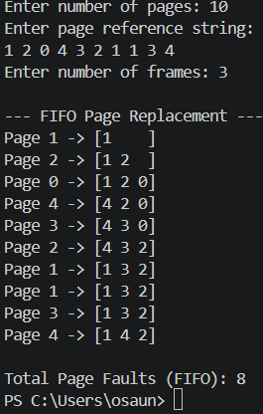

LRU
#include <stdio.h>

int main() {
int pages[50], frames[10], time[10];
int n, f, i, j;
int pageFaults = 0;
int counter = 0;
int found, pos, min;

printf("Enter number of pages: ");
scanf("%d", &n);

printf("Enter page reference string:\n");
for(i = 0; i < n; i++) {
scanf("%d", &pages[i]);
}

printf("Enter number of frames: ");
scanf("%d", &f);

for(i = 0; i < f; i++) {
frames[i] = -1;
time[i] = 0;
}

printf("\n--- LRU Page Replacement ---\n");

for(i = 0; i < n; i++) {

found = 0;

for(j = 0; j < f; j++) {
if(frames[j] == pages[i]) {
found = 1;
counter++;
time[j] = counter;
break;
}
}

if(found == 0) {

pos = -1;

for(j = 0; j < f; j++) {
if(frames[j] == -1) {
pos = j;
break;
}
}

if(pos != -1) {
frames[pos] = pages[i];
counter++;
time[pos] = counter;
}
else {
min = 0;

for(j = 1; j < f; j++) {
if(time[j] < time[min]) {
min = j;
}
}

frames[min] = pages[i];
counter++;
time[min] = counter;
}

pageFaults++;
}

printf("Page %d -> [", pages[i]);

for(j = 0; j < f; j++) {
if(frames[j] != -1)
printf("%d", frames[j]);
else
printf(" ");

if(j != f - 1)
printf(" ");
}

printf("]\n");
}

printf("\nTotal Page Faults (LRU): %d\n", pageFaults);

return 0;
}
OUTPUT
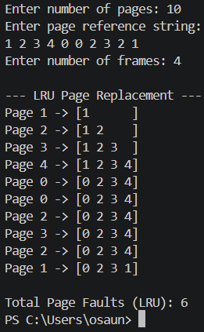

ORU
#include <stdio.h>

int main() {
int pages[50], frames[10];
int n, f, i, j, k;

int pageFaults = 0;
int found, pos, farthest, index;

printf("Enter number of pages: ");
scanf("%d", &n);

printf("Enter page reference string:\n");
for(i = 0; i < n; i++) {
scanf("%d", &pages[i]);
}

printf("Enter number of frames: ");
scanf("%d", &f);

for(i = 0; i < f; i++) {
frames[i] = -1;
}

printf("\n--- Optimal Page Replacement ---\n");

for(i = 0; i < n; i++) {

found = 0;

for(j = 0; j < f; j++) {
if(frames[j] == pages[i]) {
found = 1;
break;
}
}

if(found == 0) {

pos = -1;

for(j = 0; j < f; j++) {
if(frames[j] == -1) {
pos = j;
break;
}
}

if(pos != -1) {
frames[pos] = pages[i];
}
else {

farthest = -1;
index = -1;

for(j = 0; j < f; j++) {

int foundFuture = 0;

for(k = i + 1; k < n; k++) {
if(frames[j] == pages[k]) {

if(k > farthest) {
farthest = k;
index = j;
}

foundFuture = 1;
break;
}
}

if(foundFuture == 0) {
index = j;
break;
}
}

frames[index] = pages[i];
}

pageFaults++;
}

printf("Page %d -> [", pages[i]);

for(j = 0; j < f; j++) {

if(frames[j] != -1)
printf("%d", frames[j]);
else
printf(" ");

if(j != f - 1)
printf(" ");
}

printf("]\n");
}

printf("\nTotal Page Faults (Optimal): %d\n", pageFaults);

return 0;
}
OUTPUT
